# INFO1111: Computing 1A Professionalism

# 2024 Semester 1

# 

# Self-Learning Report

# Task 1: Foundation: Learning Jira

# Student Name: Kedar

# Student ID: 520572296

# Submission number: 2

# Github link: https://github.com/PureOreo/INFO1111-Self-Learning

# **Instructions**

# ***Important:*** *This section should be removed prior to submission.*

# You should use this template to generate your self-learning report. Keep in mind the following key points:

# **Submissions**: There will be three opportunities during the semester to submit this report. For each submission you can attempt one task (the Foundation Report is Task 1 ) and aim for a rating of ‘OK’ or ‘STRONG’. Each submission should use the same report template, but amended to include new information. You can only attempt the advanced task (the Advanced Report is Task 2) after you have achieved a ‘STRONG’ on the foundation task.

# **Minimum requirement:** Remember that in order to pass the unit, you must achieve at least a rating of ‘OK’ on ‘Self-Learning Report (Task 1: Foundation)’.

# **Using this template:** When completing each section you should remove the explanation text and replace it with your material.

# **Referencing:** You should also ensure that any resources you use are suitably referenced, and references are included into the reference list at the end of this document. You should use the IEEE reference style [1] (the reference included here shows you how this can be easily achieved)

# **Overview of the tool/technology to be self-learnt**

JIRA, developed by Atlassian, is a project management tool widely used for organising tasks and projects. It can be used for various project management methodologies such as agile, waterfall, and hybrid approaches as it provides flexibility for different team preferences. Beyond task tracking, JIRA facilitates seamless collaboration among team members through features like file sharing and communication tools.

Knowing how to use JIRA is an important skill to have for a number of reasons, to list a few:

* **Real-world application:** JIRA is widely used in the industry for project management, issue tracking, and agile development. Knowing how to navigate and utilise JIRA effectively gives you practical skills that are directly applicable in your future careers.
* **Collaboration and teamwork:** Many IT projects involve collaboration among team members, sometimes across different locations or time zones. JIRA provides a centralised platform for teams to coordinate tasks, communicate updates, and track progress, fostering efficient teamwork.
* **Organisational skills:** JIRA encourages structured organisation of tasks, priorities, and workflows. Learning to use JIRA can help develop skills in task prioritisation, time management, and project planning, which are essential for success in IT projects.
* **Career readiness:** Proficiency in JIRA is often listed as a desirable skill in jobs for IT-related roles.

**Steps and ratings for self-learning Jira**

The following is a list of steps you need to carry out to meet the goals of this report. For each step you must provide evidence that you have successfully carried out that step, as described in Section 4. above.

***Note:*** *the minimum requirements have been provided below, however depending on how you do these you may need to create additional issues (epics, tasks, sub-tasks, stories, bugs etc.) in some instances.*

**OK Rating**

To achieve an “OK” rating you will need to self-learn how to do and demonstrate all of the following in JIRA:

1. Create a project and name it ‘INFO1111_SEM1_2024’

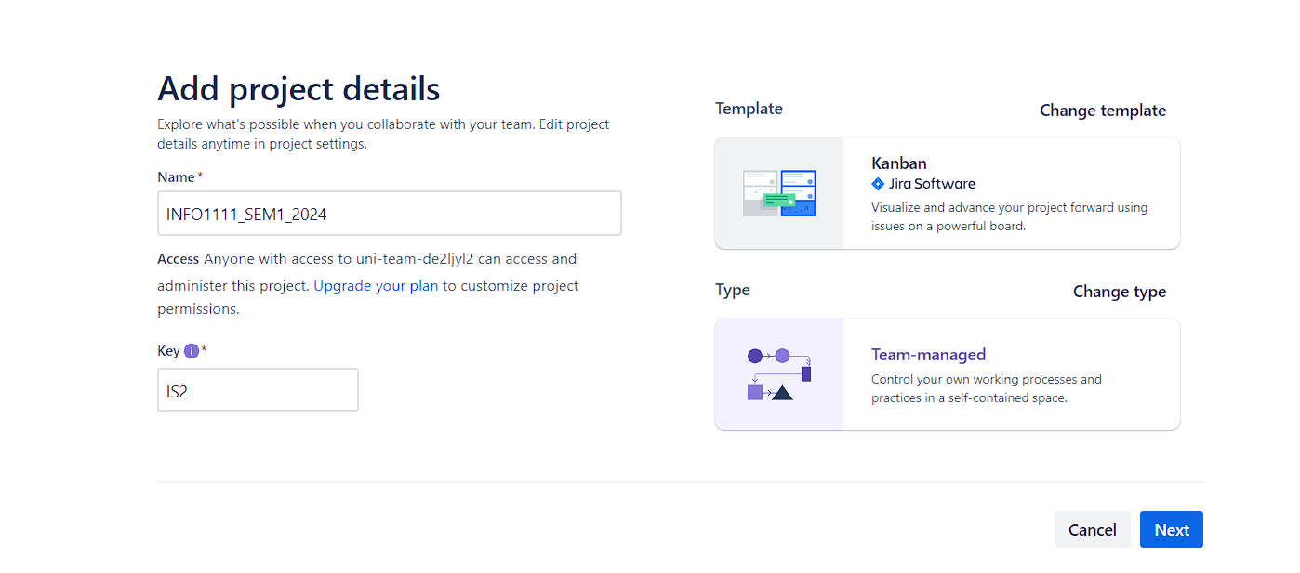

1. Create 2 epics.

1. Create 2 stories, 2 tasks and 2 bugs under each epic from task 2.

1. Create 3 sub-tasks under each of the tasks created in task 3.

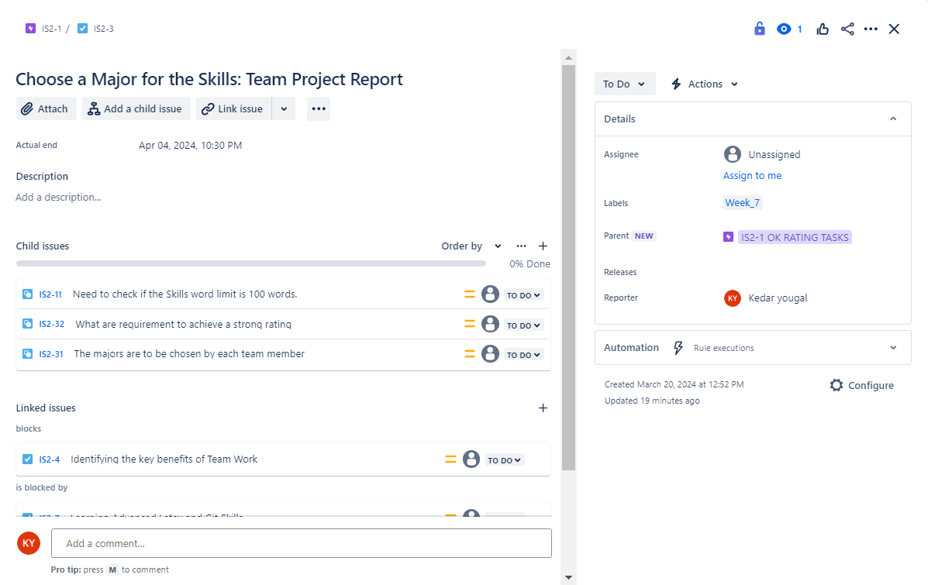

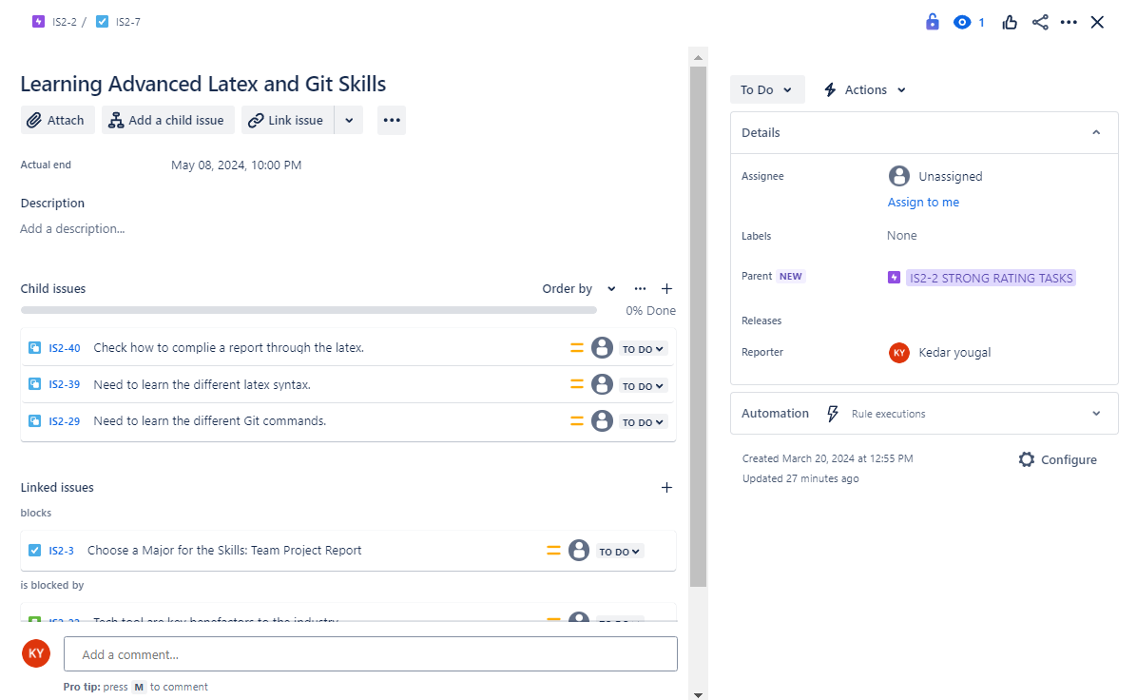

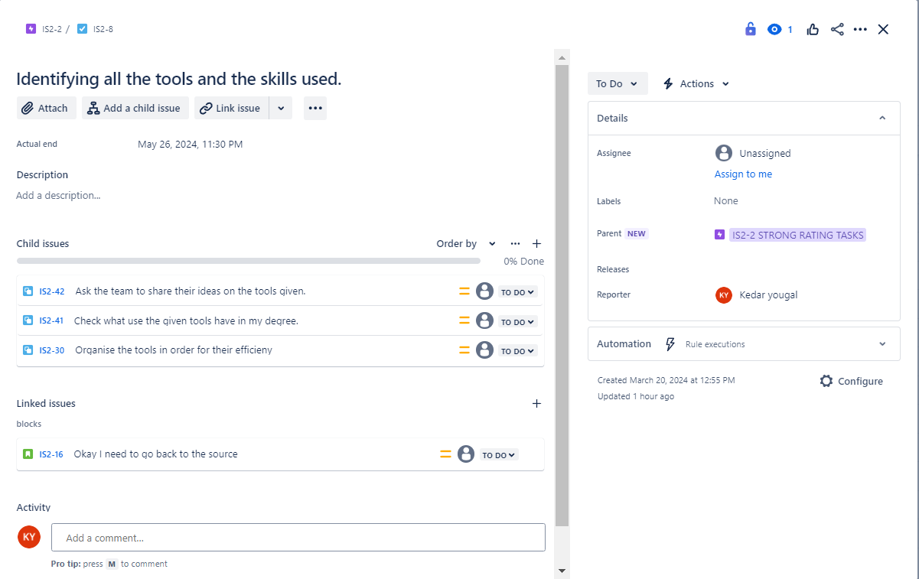

1. Create links between the above epics, tasks, stories, bugs and sub-tasks you have created in 2 - 5. The following links should be present between any 2 of the above issues you have created:
2. 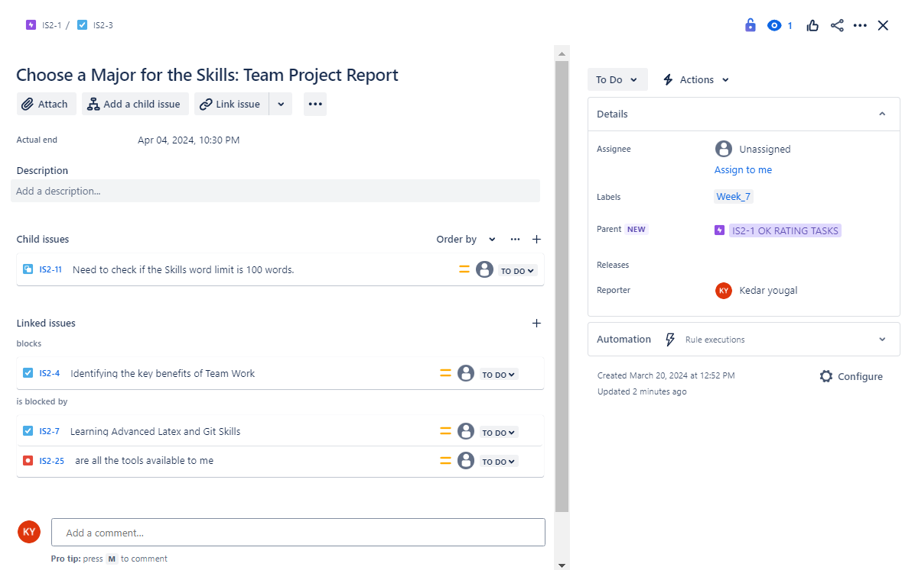blocks/is blocked by

1. duplicates/is duplicated by

1. Attach a file to any one of the issues.

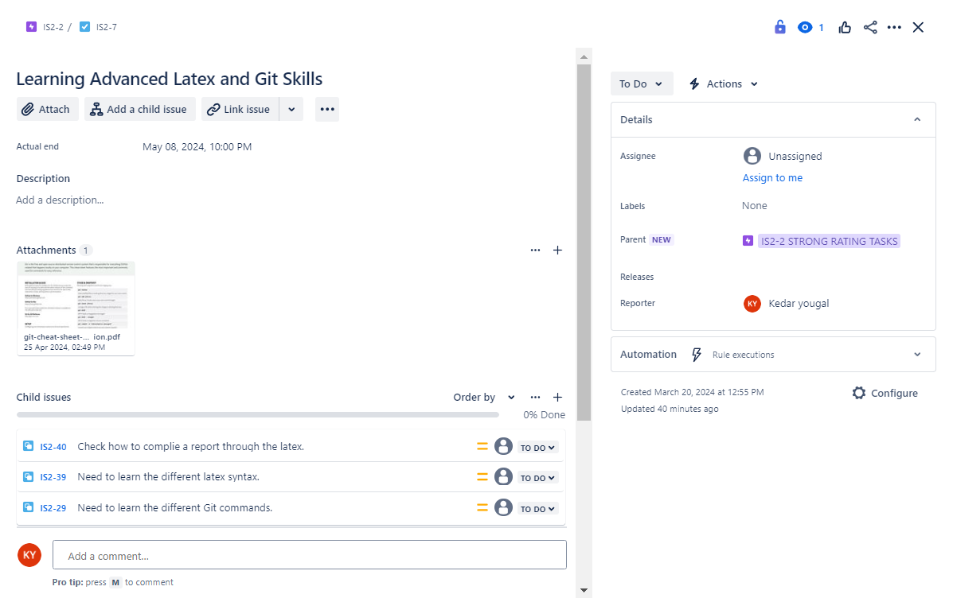

1. Add the following to at least 3 of the issues:
2. Description

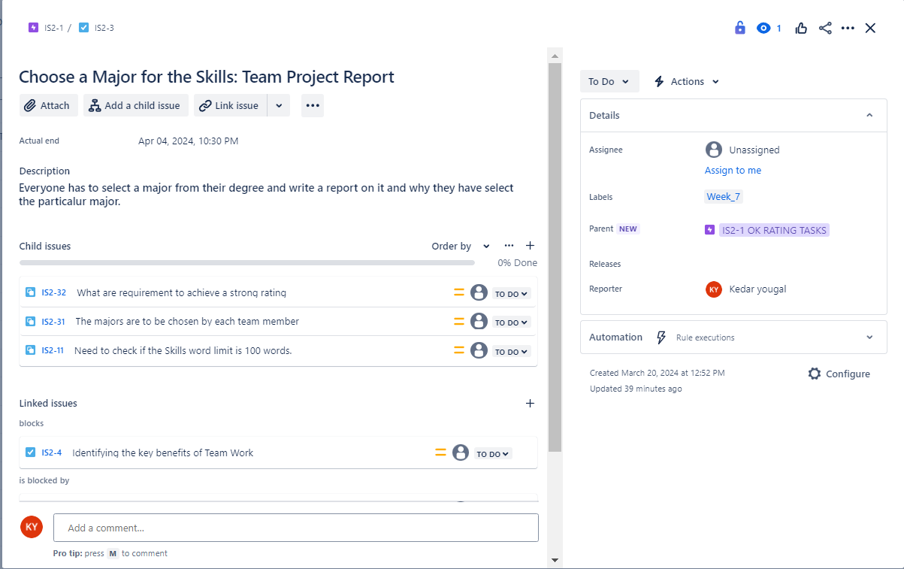

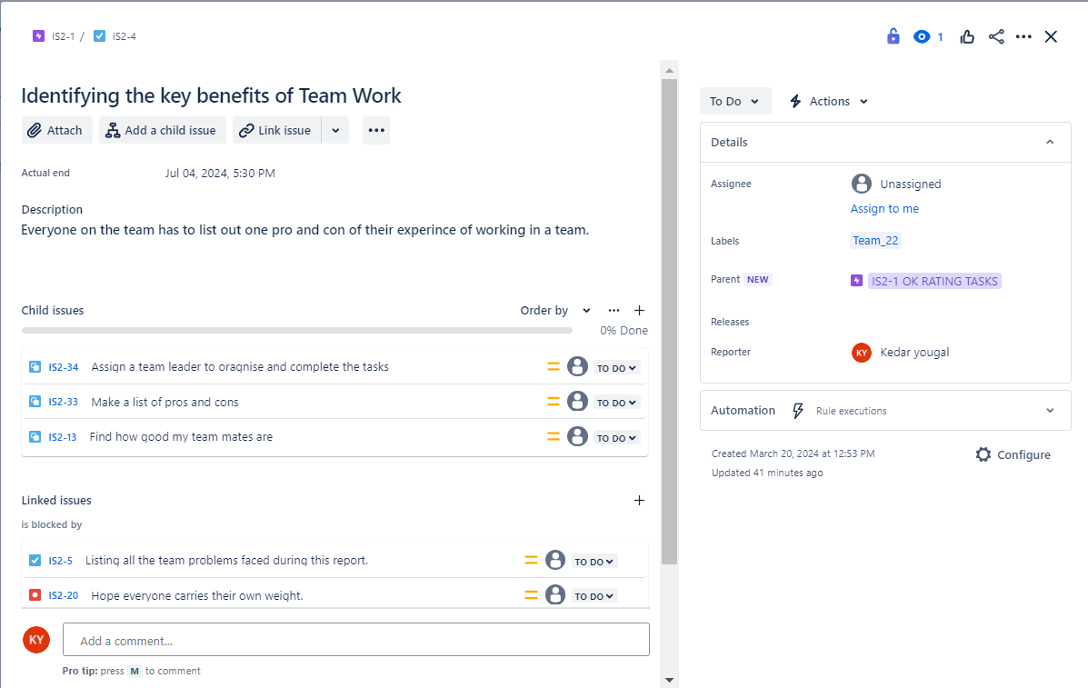

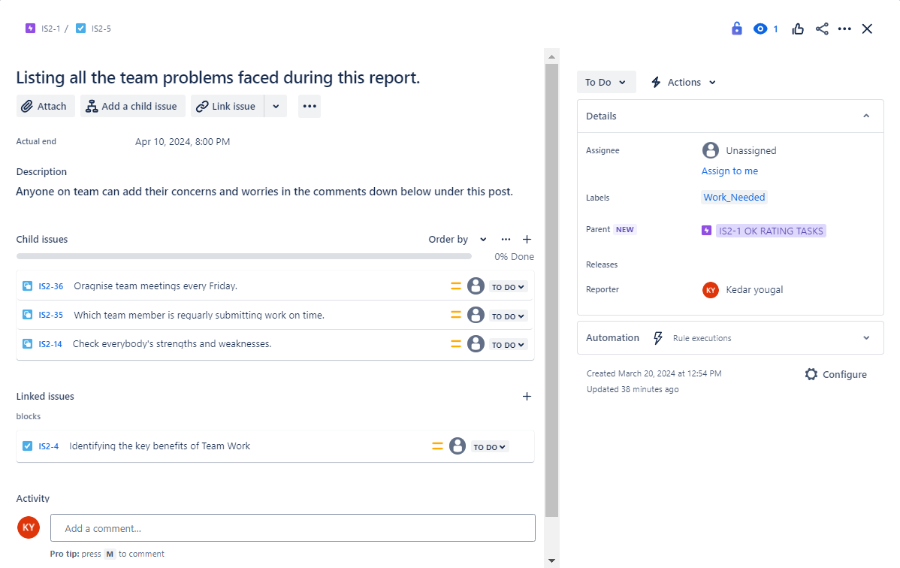

1. Labels

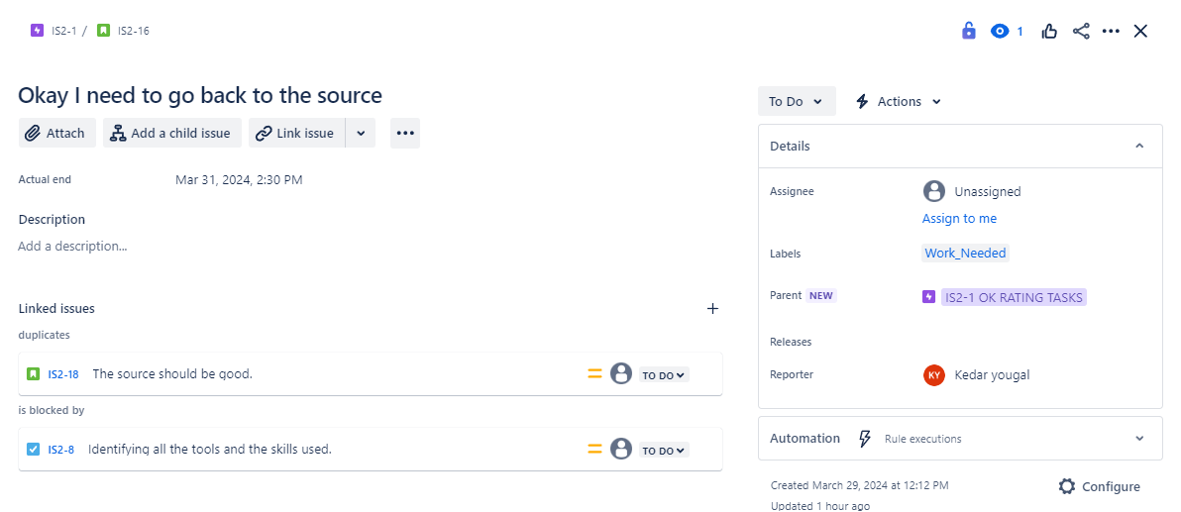

1. Create a filter that filters only for the ‘bugs’ that you have created.

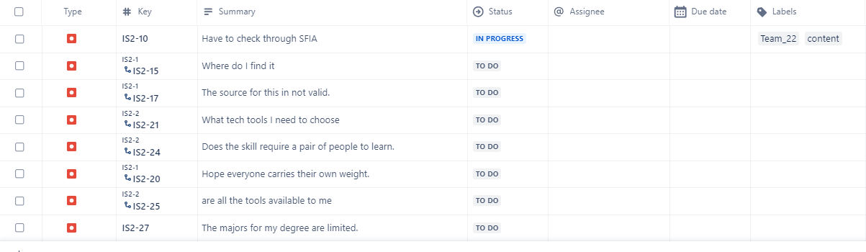

1. Add due dates to all of the issues you have created so far (note: it is important that you set different dates for each of the issues if you intend to aim for a “STRONG” rating)

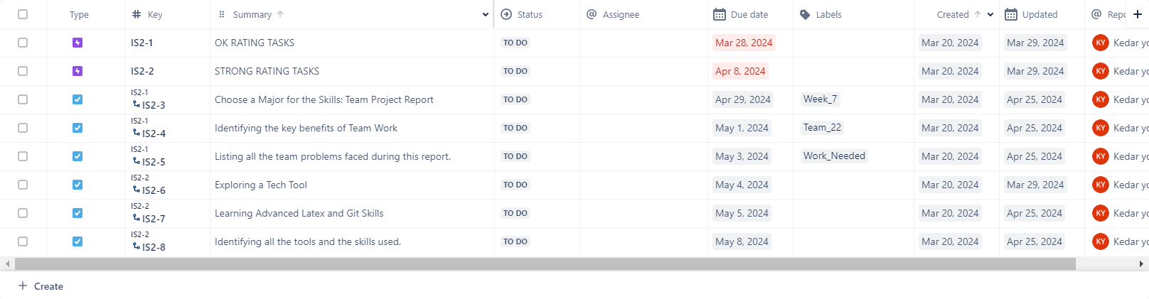

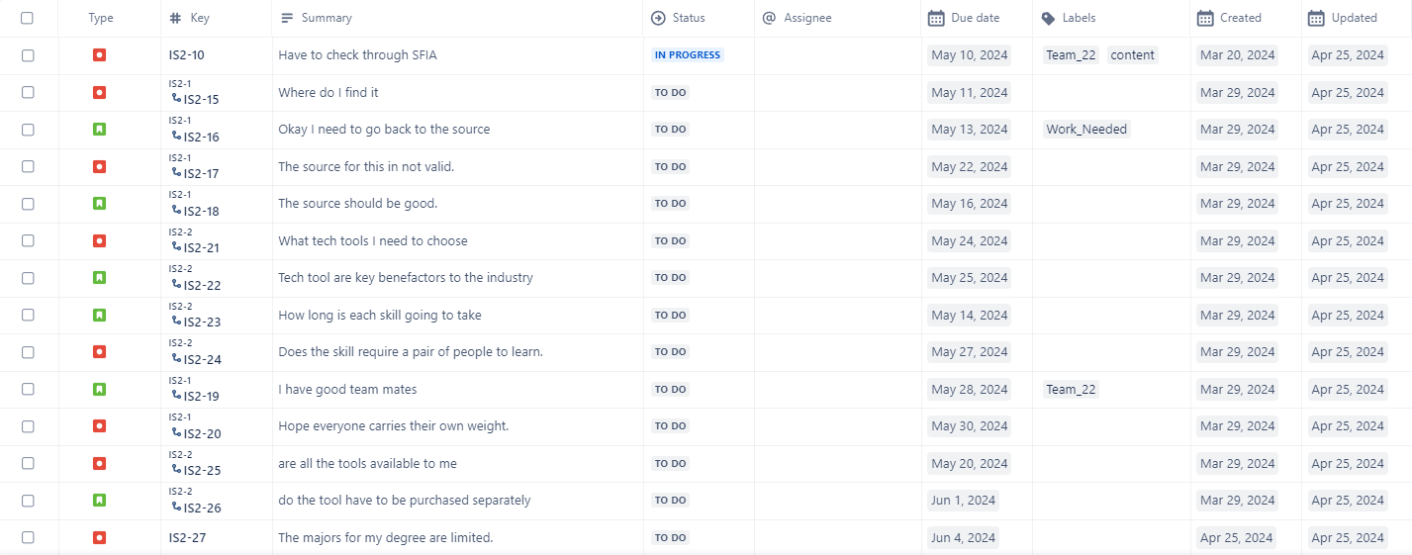

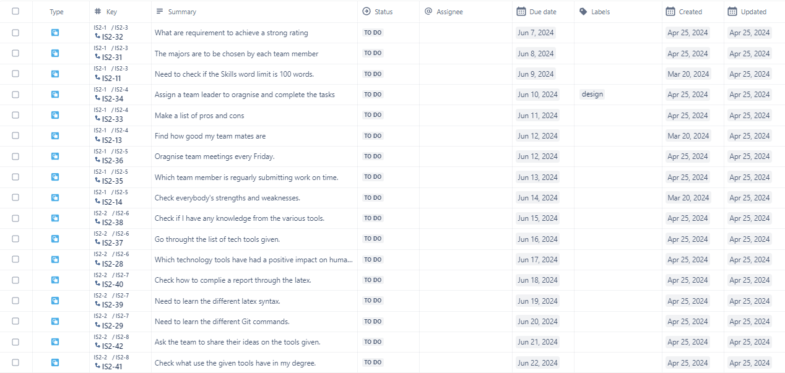

**STRONG Rating**

To achieve a “STRONG” rating in addition to the above you will need to self-learn how to do and demonstrate all of the following in JIRA:

1. Create a schedule timeline that includes all the issues you have created and provides a child-level issue view.
2. Create a dashboard with at least 3 different kinds of gadgets that present different information on the issues you have created.
3. Create an automation (do not use the templates provided as is, you must modify them or make your own).

### 

### Background

* 1. **Motivations for self-learning:**

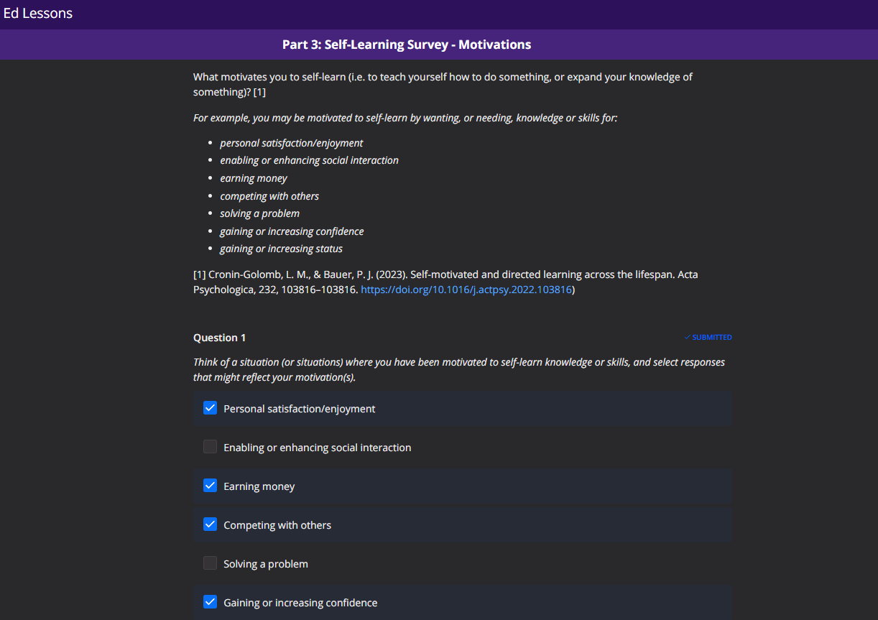

* 1. **Effective self-learning and its challenges**:
     1. What is the most effective way you currently self-learn?

When I want to learn something new, I use YouTube. I pick a topic, find relevant videos, and watch them at my own pace. I then apply what I’ve learned in real life. Finally, I review the material and repeat the process with new videos. It’s a continuous cycle of learning.

* + 1. What is the most difficult challenge for you when you are self-learning?

The most challenging aspect of self-learning for me is maintaining consistent motivation and discipline. Without a structured environment or deadlines, it’s easy to procrastinate or lose focus. Additionally, understanding complex concepts without guidance can be tough. Hence, self-learning requires strong willpower, discipline, and effective problem-solving skills.

### Journal of self-learning activities and reflections. *Use the template* *Journal of self-learning activities and reflections* *to record each of your activities as you do them, along with your thoughts about the activity. Submit this journal weekly to show and discuss in each week’s tutorial. Use the Journal as a source of information for sections 5 and 6 of this template.*

### Self-learning Plan

* 1. **Goals**:

Your goals for this report are to:

1. Demonstrate your knowledge (understanding) of Jira by carrying out the steps 1-12 in the instructions.
2. Demonstrate your skill in applying that knowledge to creating artefacts using Jira by carrying out the steps 1-12 in the instructions.
3. Evaluate your self-learning processes.
   1. **Schedule**
      1. *List and describe the steps you will take to execute your plan and when you will complete them.*

|  |  |  |
| --- | --- | --- |
| **STEPS NO** | **DESCRIPTION** | **DATE** |
| 1 |  |  |
|  |  |  |
|  |  |  |
|  |  |  |
|  |  |  |
|  |  |  |

### Results: evidence of the steps you have attempted from the instructions

Provide evidence for each step you have completed (e.g. in the form of screenshots with annotations that explain what you have done in this screenshot and how it represents that).

### Evaluation

* 1. Knowledge and skills

|  |  |
| --- | --- |
| **QUESTIONS** | **YOUR ANSWER** |
| 1. To what extent did you reach the goals for this report? |  |
| 1. What barriers did you face in reaching the goals? |  |
| 1. What worked well for you in doing the report? |  |
| 1. What was frustrating? |  |
| 1. Other?..... |  |

* 1. Self-learning learning processes

|  |  |
| --- | --- |
| **QUESTIONS** | **YOUR ANSWER** |
| 1. What worked? |  |
| 1. What didn’t? |  |
| 1. What would you do differently? |  |
| 1. What did you learn about yourself? |  |
| 1. What recommendation would you make to your future self? |  |
| 1. What would you recommend to someone else? |  |
| 1. Other?..... |  |

### Learning sources

Learning Source - What source did you use? (Note: Include source details such as links to websites, videos etc.). Contribution to Learning - How did the source contribute to your learning (i.e. what did you use the source for?). You may use information from your Journal for this.

|  |  |
| --- | --- |
| Learning Source - What source did you use? (Note: Include source details such as links to websites, videos etc.). | Contribution to Learning - How did the source contribute to your learning (i.e. what did you use the source for)? |
|  |  |
|  |  |
|  |  |
|  |  |
|  |  |

**Bibliography**

[1] The University of Sydney, _Referencing and citation styles: IEEE,_ 2022, see https:

//libguides.library.usyd.edu.au/c.php?g=508212.